IKO翻 I

KEYENCE

**AS Series**

**Inductive Displacement Sensors**

**INSTRUCTION MANUAL**

Thank you for purchasing the KEYENCE Inductive Displacement Sensor AS series.

As a leading manufacturer of high-tech sensors and measuring instruments for industrial applica­tions, we use our unique vast technical experience to develop revolutionary products that meet the needs of our customers. We have obtained a high reputation for our thorough and coherent quality control and post-sales service.

Please read this manual carefully to get the most from the AS series.

**Contents**

Part Names 3

Connections 3

Adjustment 4

Precautions 4

Hints on Correct Use 5

Zero/span Adjustable Range 6

Output Characteristics for Disc Target Diameter

Measurement (typical) 7

Output Characteristics for Cylindrical Target

Diameter Measurement (typical) 7

Response Frequency vs. Output

Characteristics (typical) 8

Output Characteristics for Non-ferrous Metal

Measurement (typical) 8

Specifications 9

Dimensions 10

WARRANTIES 11

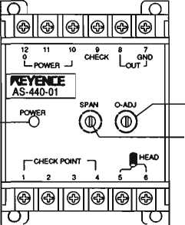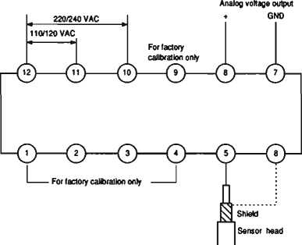Note: **DO NOT CHANGE THE SENSOR CABLE LENGTH (3** m). If you extend or cut the cable, its characteristics will change.

POWER Indicator

Zero-adjuster tfimmer (For zero point adjustment)

Span-adjuster trimmer (For inclination adjustment)

Be sure that the cable length is 3 m even if it is cut and connected to a connector. (Use a BNC type connector.)

Adjustment

Though all the necessary internal adjustments have been made at the factory, check the following during actual operation.

1. Connect the voltmeter to the amplifier unit and check whether analog output voltage is 0 VDC by placing the sensor in contact with the object being detected. If the reading of the voltmeter is not 0 VDC, adjust it using the zero-adjuster trimmer.
2. Set the distance between the sensor and the object to 1/2 of the measuring range of the sensor. Then inspect whether analog output voltage conforms to the specifications.

If the analog output voltage does not conform to the specifications, adjust it using the span-adjuster trimmer.

1. Again place the sensor in contact with the object being detected, and inspect whether the reading of the voltmeter is 0 VDC. If the reading is not zero, repeat the adjusting procedures ① and ②.

Precautions

Since this product has been adjusted as a pair of a controller and sensor head, be sure to use a matched pair whose components have the same number.

A change in characteristics occurs if you change the unit combination, requiring re-adjustment at the factory.

The standard object to be detected is iron (SS41).

Be aware that the characteristics will change if non-ferrous metals are detected. (Refer to page 7.)

參 **Sensor cable**

Do not change the sensor cable length (3 m). If you extend or cut the cable, its characteristics will change.

Hints on Correct Use

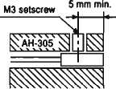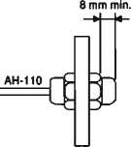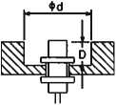

參 **Mutual interference**

When more than two sensor heads of the same model are installed in parallel, mutual interference may occur, providing abnormal voltage.

Be sure to place a distance between two adjacent sensor heads accord­ing to the values shown in the table below.

(When satisfying a resolution of 0.1%)

| **Distance**  **Model** | **In parallel**  丄(=j= 丁 口= |
| --- | --- |
| AH-305 | 36 |
| AH-110 | 80 |
| AH-416 | 116 |
| AH-422 | 142 |

**• Installing sensor**

As shown in the figure at right, in­stall and tighten the AH-305 setscrew and AH-110 nut to the specified positions away from the tip of the sensor.

**• Flush-mounted sensor**

As shown in the figure at right, make a spot facing when flush­mounting each sensor in metal.

When required accuracy is lower than the specifications, you can place the sensor closer than the value shown in the table on the right. Please contact us for more details.

|  |  |  |
| --- | --- | --- |
| **ance (mm)**  **Model** | **d** | **D** |
| AH-305 | 12 | 9 |
| AH-110 | 12 | 9 |
| AH-416 | 35 | 10 |
| AH-422 | 55 | 20 |

Zero/span Adjustable Range

|  |  |  |
| --- | --- | --- |
| **Adjustable**  **Controller** | **Zero adjustabl ❷ range**  **A(V)** | **Span adjustable range**  **B(V)** |
| AS-440-01 | -0.5 to +0.1 | -0.15 to+0.15 |
| AS-440-02 | -1.0 to+0.2 | -0.3 to +0.3 |
| AS-440-05 | -2.5 to +0.5 | -0.75 to +0.75 |
| AS-440-10 | -5.0 to +1.0 | -1.5 to+1.5 |

*: At a distance of 1/2 of the measuring range

**Zero adjustable range (AS-440-02)**

**Span adjustable range (AS-440-02)**

00<06 eys Indlno

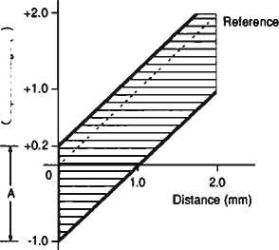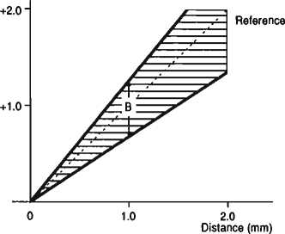

Output Characteristics for Disc

Target Diameter Measurement (typical)

If object diameter is more than 1.8 times the sensor head diameter, the linear output range will cover the entire measuring range.

Output Characteristics for Cylindrical Target Diameter Measurement (typical)

If object diameter is more than 1.1 times the sensor head diameter, the linear output range will cover the entire measuring range.

**irxhno JBSn**

|  |  |
| --- | --- |
|  |  |
|  |  |

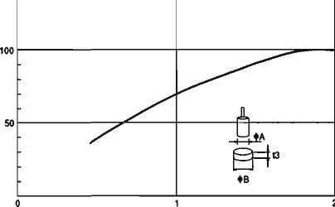

Response Frequency vs.

Output Characieristics (typical)

Though analog output voltage decreases according to a response fre­quency of more than 3.3 kHz, you can use the sensor if you need its repeat accuracy only.

Output Characteristics for

Non-ferrous Metal

Measurement (typical)

These are the characteristics when zero and span adjusting conditions are considered as standard (object: iron SS41).

Units exclusively for non-ferrous metal (for A^, Cu, SUS) are available when you require linearity. Please contact us for more details.

ffis Irx^no

**1k**

**5k**

**10k Hz**

o

3.

**AS~440~02 (Tgpfcal)**

**Cull**

7

**；SUS410L**

**SS41**

**1.0 2.0 3.0**

**Distance (mm)**

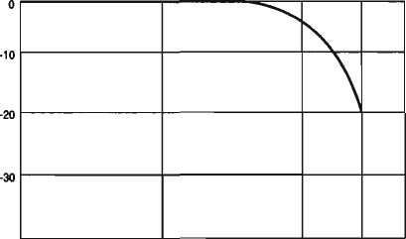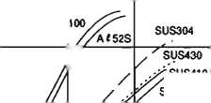

**Specifications**

|  |  |  |  |  |  |
| --- | --- | --- | --- | --- | --- |
| **Type** | | **Cylindrical** | **Threaded** | **Cylindrical & Threaded** | |
| **Model** | **Sensor head** | **AH-305** | **AH-110** | **AH-416** | **AH-422** |
| **Controller** | **AS«440-01** | **AS-440-02** | **AS-440-05** | **AS-440-10** |
| **Measuring range** | | 0 to 1 mm | 0 to 2 mm | 0 to 5 mm | 0 to 10 mm |
| **Analog voltage output** | **Output voltage** | Oto 1 V | 0to2 V | 0to5V | Oto 10V |
| **Output impedance** | 100 Q | | | |
| **Resolution** | 0.1%of F.S. | | | |
| **Linearity** | ±0.1% of F.S. | | | |
| **Response frequency** | DC to 3.3 kHz (-3 dB) | | | |
| **Temperature fluctuation** | **Sensor head** | 0.03% of F.S./°C | | | |
| **Controller** | 0.05% of F.S./°C | | | |
| **Power supply** | | 110/120/220/240 VAC ±10%, 50/60 Hz | | | |
| **Power consumption** | | 5VA | | | |
| **Ambient temperature** | **Sensor head** | -10 to 60°C (14 to 140°F), No freezing | | | |
| **Controller** | 0 to 50°C (32 to 122°F), No freezing | | | |
| **Relative humidity** | | 35 to 85%, No condensation | | | |
| **Vibration** | | 10 to 55 Hz, 1.5 mm double amplitude in X, Y, and Z direction, 2 hours respectively | | | |
| **Weight** | **Sensor head** | Approx. 45 g | Approx. 55 g | Approx. 75 g | Approx. 200 g |
| **Controller** | Approx. 320 g | | | |

Notes

1. This product is not convertible since it has been calibrated as a matched pair of controller and sensor head.
2. The values in the above table were measured using an iron work piece as the target. Sensors exclusively for stainless steel, copper, or aluminum are available. Please contact us for more details.

Dimensions (unit:mm)

**• Controller**

參 **Sensor head (with 3-m coaxial cable)**

**AH-305**

**AH-110**

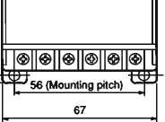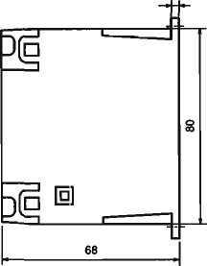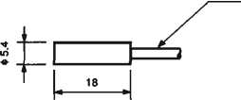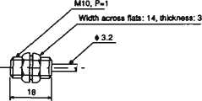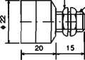

06

6in03) s

**4-45 '(Mounting hole)**

**4**

**AH-416**

**Width across "as: 19, thickness: 3.5**

*s*

s.n*-

20

**AH-422**

**WARRANTIES**

**WARRANTIES AND DISCLAIMERS:**

1. KEYENCE warrants the Products to be free of defects in materials and workmanship for a period of one (1) year from the date of shipment. If any models or samples were shown to Buyer, such models or samples were used merely to illustrate the general type and quality of the Products and not to represent that the Products would necessarily conform to said models or samples. Any Products found to be defective must be shipped to KEYENCE with all shipping costs paid by Buyer or offered to KEYENCE for inspection and examina­tion. Upon examination by KEYENCE, KEYENCE, at its sole option, will refund the purchase price of, or repair or replace at no charge any Products found to be defective. This warranty does not apply to any defects resulting from any action of Buyer, including but not limited to improper installation, improper interfacing, improper repair, unauthorized modification, misapplication and mishandling, such as exposure to excessive current, heat, coldness, moisture, vibration or outdoors air. Components which wear are not warranted.
2. KEYENCE is pleased to offer suggestions on the use of its various Products. They are only suggestions, and it is Buyer’s responsi­bility to ascertain the fitness of the Products for Buyer’s intended use. KEYENCE will not be responsible for any damages that may result from the use of the Products.
3. The Products and any samples ("Products/Samples^^) supplied to Buyer are not to be used internally in humans, for human transportation, as safety devices or fail-safe systems, unless their written specifications state otherwise. Should any Products/Samples be used in such a manner or misused in any way, KEYENCE assumes no responsibility, and additionally Buyer will indemnify KEYENCE and hold KEYENCE harmless from any liability or damage whatsoever arising out of any misuse of the Products/Samples.
4. OTHER THAN AS STATED HEREIN, THE PRODUCTS/SAMPLES ARE PROVIDED WITH NO OTHER WARRANTIES WHATSO­

EVER. ALL EXPRESS, IMPLIED, AND STATUTORY WARRANTIES, INCLUDING, WITHOUT LIMITATION, THE WARRANTIES OF MERCHANTABILITY, FITNESS FOR A PARTICULAR PURPOSE, AND NON-INFRINGEMENT OF PROPRIETARY RIGHTS, ARE EXPRESSLY DISCLAIMED. IN NO EVENT SHALL KEYENCE AND ITS AFFILIATED ENTITIES BE LIABLE TO ANY PERSON OR ENTITY FOR ANY DIRECT, INDIRECT, INCIDENTAL, PUNITIVE, SPECIAL OR CONSEQUENTIAL DAMAGES (INCLUDING, WITH­OUT LIMITATION, ANY DAMAGES RESULTING FROM LOSS OF USE, BUSINESS INTERRUPTION, LOSS OF INFORMATION, LOSS OR INACCURACY OF DATA, LOSS OF PROFITS, LOSS OF SAVINGS, THE COST OF PROCUREMENT OF SUBSTITUTED GOODS, SERVICES OR TECHNOLOGIES, OR FOR ANY MATTER ARISING OUT OF OR IN CONNECTION WITH THE USE OR INABILITY TO USE THE PRODUCTS, EVEN IF KEYENCE OR ONE OF ITS AFFILIATED ENTITIES WAS ADVISED OF A POSSIBLE THIRD PARTY'S CLAIM FOR DAMAGES OR ANY OTHER CLAIM AGAINST BUYER. In some jurisdictions, some of the foregoing warranty disclaimers or damage limitations may not apply. "

**BUYERfS TRANSFER OBLIGATIONS:** If the Products/Samples purchased by Buyer are to be resold or delivered to a third party, Buyer must provide such third party with a copy of this document, all specifications, manuals, catalogs, leaflets and written information provided to Buyer pertaining to the Products/Samples.

**KEYENCE CORPORATION**

[www.keyence.com](http://www.keyence.com)

**Specifications are subject (o change without notice.**

1-3-14, Higashi-Nakajima, Higashi-Yodogawa-ku, Osaka, 533-8555, Japan PHONE： +81-6-6379-2211